**Project Design Phase-II**

**Data Flow Diagram & User Stories**

| Date | 03 October 2022 |
| --- | --- |
| Team ID | PNT2022TMID43213 |
| Project Name | Project -Real-Time Communication System Powered by AI for Specially Abled |
| Maximum Marks | 4 Marks |

**Data Flow Diagrams:**

A Data Flow Diagram (DFD) is a traditional visual representation of the information flows within a system. A neat and clear DFD can depict the right amount of the system requirement graphically. It shows how data enters and leaves the system, what changes the information, and where data is stored.

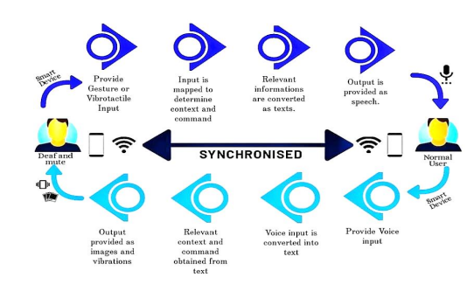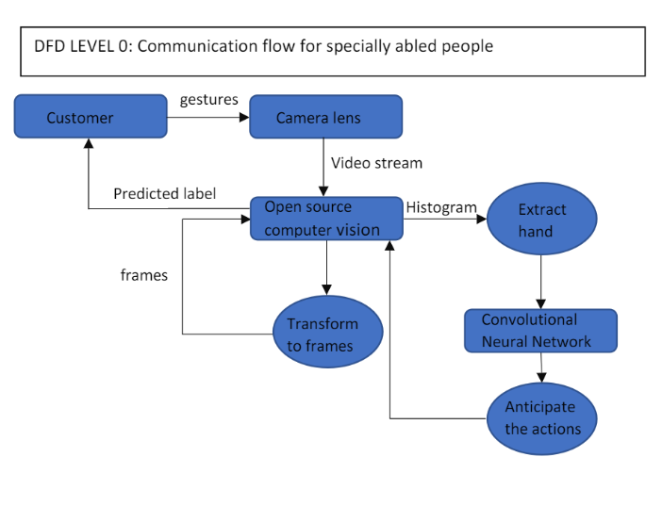

**User Stories**

Use the below template to list all the user stories for the product.

| **User Type** | **Functional Requirement (Epic)** | **User Story Number** | **User Story / Task** | **Acceptance criteria** | **Priority** | **Release** |
| --- | --- | --- | --- | --- | --- | --- |
| Customer (Mobile user) | Registration | USN-1 | As a user, I can register for the application by entering my email, password, and confirming my password. | I can access my account / dashboard | High | Sprint-1 |
|  |  | USN-2 | As a user, I will receive confirmation email once I have registered for the application | I can receive confirmation email & click confirm | High | Sprint-1 |
|  |  | USN-3 | As a user, I can register for the application through Facebook | I can register & access the dashboard with Facebook Login | Low | Sprint-2 |
|  |  | USN-4 | As a user, I can register for the application through Gmail | via some third parties link | Medium | Sprint-2 |
|  | Login | USN-5 | As a user, I can log into the application by entering email & password | I can type manually and also can used saved login credentials | High | Sprint-1 |
|  | Dashboard | USN-6 | As a customer,I can get all services and help in dashboard | I can access my dashboard and change profile | Medium | Sprint-2 |
| Customer (Web user) | Registration | USN-7 | As a customer, I could able to login through registered phone number by using otp instead of Gmail | I could able to register & login via phone number to access my account | High | Sprint-2 |
| Customer Care Executive | service | USN-8 | Can avail the service by calling customer care or reaching through E-mail. | Can avail the service by calling customer care or reaching through E-mail. | Medium | Sprint-1 |
| Administrator |  | USN-9 | Respective person in the company should take care all of this. | All the requirements are there. | Medium | Sprint-2 |
|  | Sign up | USN-10 | Customer have to sign-up to use these things and all | Have to enter valid credentials. | High | Sprint-2 |